Clinical Competencies Framework (https://fen.uk.com/competency-framework/)
The Faculty of Emergency Nursing (FEN) concept was initiated around 1997 with the intention of developing an emergency nursing course at a basic and advanced level (Jones 2021:166). Since this time, a FEN framework has been developed by hundreds of Emergency Nurses, has gone through a few revisions and identifies practice at three levels: associate (AFEN), member (MFEN) and fellow (FFEN). In August 2018, we had completed our latest revision of the competencies and started a journey of developing the competencies into a qualification at all three levels so that emergency nurses could gain academic credits for their clinical work, knowledge and capabilities. We recognised that there were robust programmes available to develop our emergency nurse into autonomous practitioners but limited programmes to develop emergency nurses into rounded competent practitioners (AFEN), sister/charge nurse / clinical nurse managers (MFEN) and consultant nurses (FFEN); so, this has been our focus.
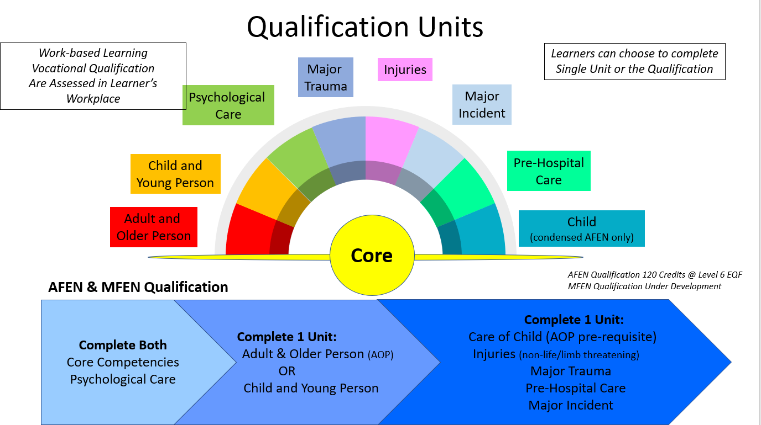
AFEN. The AFEN competencies framework (available here) has been used to underpin the development of nine units, which can be completed as single discreet units or as the qualification: Agored Cymru Level 6 Diploma in Emergency Nursing (Associate Level of Faculty of Emergency Nursing) Qualification which provides 120 academic credits on completion of four units with nine combination options. The individual units have clearly identified learning outcomes and the assessment criteria which need to be met to achieve the qualification. The learning outcomes of each of the nine units are available here [LINK to AFEN Qualification Core Learning outcomes], and an extract from the actual units which shows both the learning outcomes with their individual assessment criteria are also available here [LINK to Extract of AFEN units]. Full copies of all the units with their learning outcomes and assessment criteria are available on the members area of our website [LINK: join here]. The AFEN Education programme which supports this qualification can be joined at any time. It is included in membership and is delivered in weekly 2-hour webinars which are recorded and accessible on our members area of our website 24/7. Please note that there is an extra cost for accrediting for the qualification.
MFEN: The MFEN competencies framework (LINK: MFEN Original Competencies Framework) is being used to develop the MFEN qualification, which should be available by Spring 2022. The MFEN Education programme that supports this qualification can be joined at any time. It is included in membership and is delivered in weekly 2-hour webinars which are recorded and accessible on our members area of our website 24/7. [LINK: join here]. Please note that there is an extra cost for accrediting for the qualification.
FFEN: The FFEN competencies framework (LINK: FFEN Original Competencies Framework) is being used to develop the MFEN qualification, which should be available by Spring 2023. Later this year we will be developing an education programme for this level.

Jones G. 2021. The history of Emergency Nursing 1972 -2007. Gary J Jones CBE publications. March

